
SUBMISSION OF TASK: FUTURE INTERNS TASK 3
NAME: ADEPOJU ESTHER ITUNUOLUWA
TASK: Secure File Sharing System.
TOOLS USED: Python (Flask Framework), Cryptography Library, SQLite Database, Visual Studio Code, Miniconda (for environment setup), and MS Word (for documentation).
DETAILS: In this project, I developed a Secure File Sharing System that allows users to upload and download files safely while ensuring data confidentiality, integrity, and proper key management. The system encrypts each file using AES-256 (Galois Counter Mode) before storage, and decrypts it securely when a user downloads it.
The aim was to simulate real-world data protection mechanisms used in sectors such as healthcare, legal, and enterprise environments, where sensitive data sharing requires strong encryption and controlled access.
My Findings: The system successfully uploads, encrypts, and stores files using AES encryption. Then unique download links are generated, confirming proper backend–frontend communication. The MASTER_KEY environment variable functions correctly for secure key handling. UI feedback and deeper security validation are pending for full implementation.

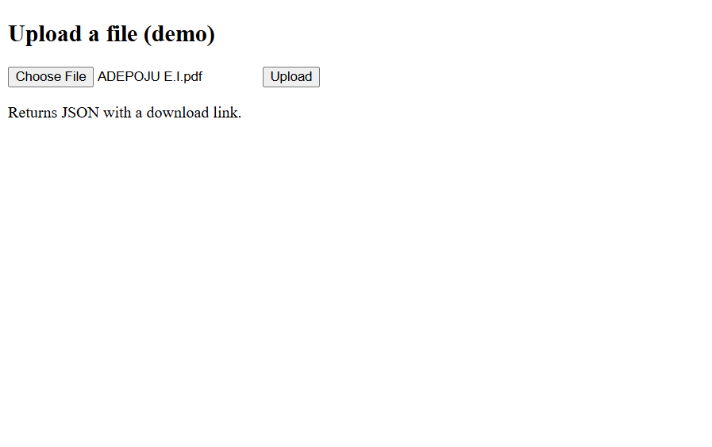
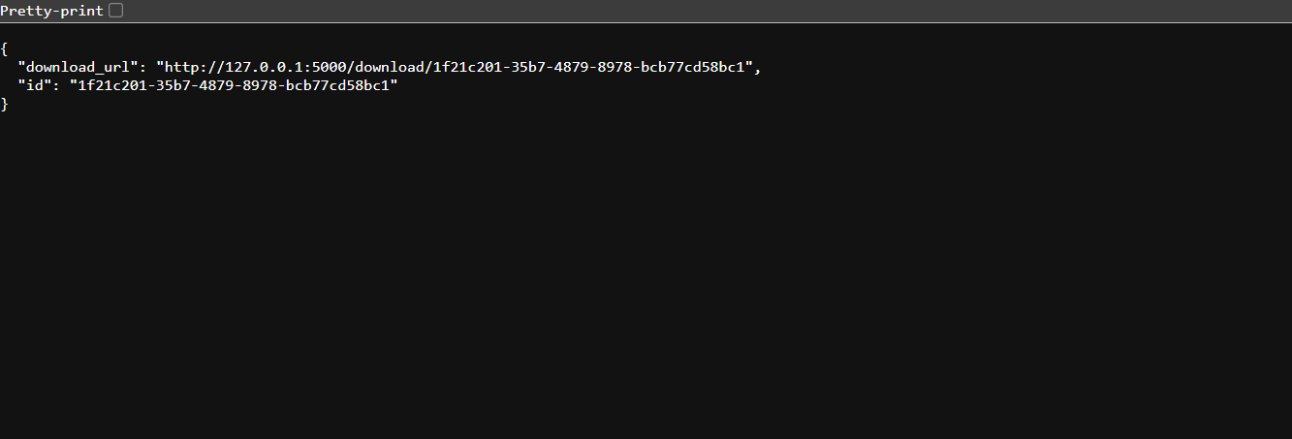

PROJECT WORKFLOW:
1. I created a Flask web portal for file upload and download.
2. I implemented AES-GCM encryption for file confidentiality and integrity protection.
3. I generated a unique 256-bit key per file and wrapped it using a system MASTER_KEY.
4. I stored encrypted files and wrapped keys securely in local storage and an SQLite database.
5. I tested end-to-end upload/download functionality to confirm successful encryption and decryption.
6. I added a styled front-end (HTML + CSS) for user interaction.

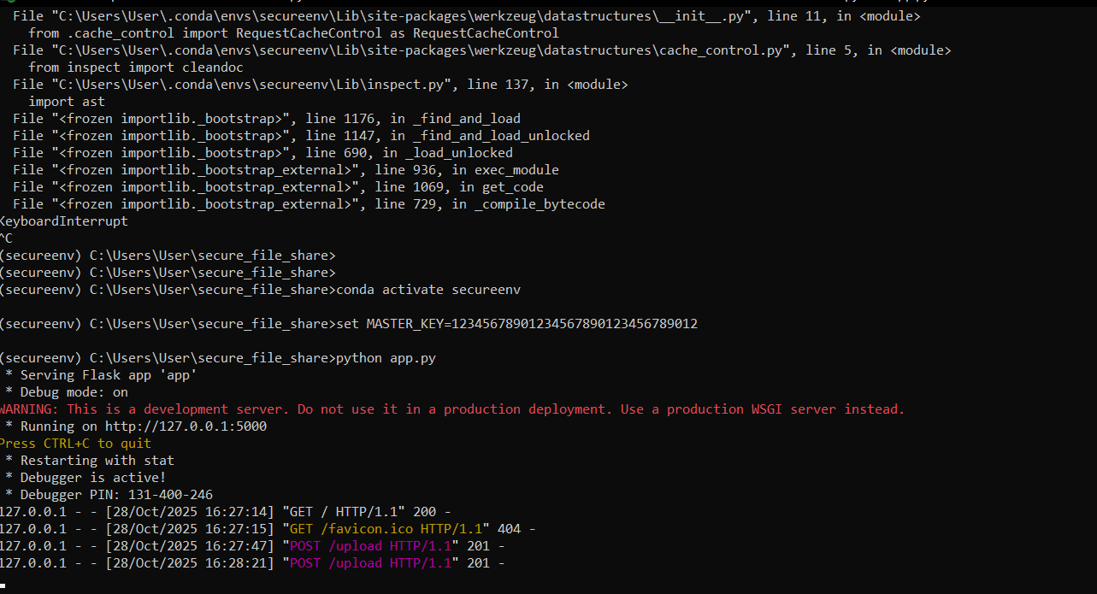

SECURITY DESIGN OVERVIEW:
Security Goal | Implementation
CONFIDENTIALITY | AES-GCM 256-bit encryption was used for all files before storage.
INTEGRITY | AES-GCM’s authentication tag ensures file tampering is detected.
KEY MANAGEMENT | MASTER_KEY stored as an environment variable; file keys are wrapped (encrypted) before storage.
SCALABILITY | Design supports integration with Key Management Services (KMS) or HSMs for enterprise-grade deployments.
TRANSPORT SECURITY
  HTTPS/TLS recommended for production environments.

IMPACT ASSESSMENT:
METRIC | DESCRIPTION
Data Confidentiality | High: even if the storage is compromised, the files remain encrypted
Data Integrity | High: tampered files cannot be decrypted without detection.
Key Security | Medium: secure under development setup, but requires KMS for production.
Usability | Moderate: system functional with scope for UI feedback improvements.

IMMEDIATE RECOMMENDATIONS:
1. Integrate HTTPS for full in-transit encryption.
2. Replace environment-stored MASTER_KEY with a managed key (AWS KMS or Azure Key Vault).
3. Implement user authentication (JWT or OAuth2) for access control.
4. Add audit logging for all upload/download activities.
5. Automate key rotation and backup encryption verification.

The Secure File Sharing System successfully demonstrates how encryption, key wrapping, and secure file management can protect data in transit and at rest. All core objectives; encryption, decryption, key security, and backend functionality, were achieved. Future improvements will focus on scaling security controls, adding user authentication, and enhancing UI interactivity.

SKILLS GAINED:
1. Data Encryption and Cryptography (AES-GCM)
2. Web Application Development (Flask Framework)
3. Secure Key Management
4. Backend Integration and Testing
5. Security Documentation and Architecture Design

